StarCellBio Design Guide

Revision history:

1. Jan 29 2013 Ivica Ceraj

Initial content

# Homepage

Visual provided:

# Macintosh HD:Users:ceraj:Dropbox:MIT_Outreach:StarCellBio App:User Interface Development:Work with Jamie Waters - Graphic Designer:Graphic Design Documents:2013 01-07:JPEGs:SCB_All_Homepage_F.jpg

Specification:

Browser white space around design:

Background color:

Homepage design:

Width:

Height:

Margin top:

Margin bottom:

Margin left:

Margin right:

Horizontal alignment:

Vertical alignment

Background color:

Design elements on this page: Header, Welcome, Central Picture, Right box, Experimental Design, Footer

## Header

Visual provided:



Specification:

Content Box:

Background color:

Width:

Height:

Green line top:

Color gradient type:

Starting color:

Ending color:

Width:

Height:

Top:

Left:

Logo:

Asset name:

Top:

Left:

Width:

Height:

URL: #view=homepage

Contact icon:

Asset name:

Top:

Left:

Width:

Height:

URL: http://star.mit.edu/feedback.html?project=StarCellBio&source=app

Contact text:

Text: “CONTACT”

Color:

Top:

Left:

Width:

Height:

Font-name:

Font-weight:

Font-size:

URL: http://star.mit.edu/feedback.html?project=StarCellBio&source=app

Vertical bar:

Asset name OR color specification:

Top:

Left:

Width:

Height:

Reference library icon:

Asset name:

Top:

Left:

Width:

Height:

Reference library text:

Text: “REFERENCE LIBRARY”

Color:

Top:

Left:

Width:

Height:

Font-name:

Font-weight:

Font-size:

Vertical bar 2:

Asset name OR color specification:

Top:

Left:

Width:

Height:

User guide icon:

Asset name:

Top:

Left:

Width:

Height:

URL: http://localhost:8000/static/pdf/StarCellBio%20User%20Guide.pdf

User guide text:

Text: “USER GUIDE”

Color:

Top:

Left:

Width:

Height:

Font-name:

Font-weight:

Font-size:

URL:

http://localhost:8000/static/pdf/StarCellBio%20User%20Guide.pdf

Vertical bar 2:

Asset name OR color specification:

Top:

Left:

Width:

Height:

SIGN IN:

Text: “SIGN IN”

Color:

Top:

Left:

Width:

Height:

Font-name:

Font-weight:

Font-size:

URL: #view=assignments

## Footer

Visual provided:



Specification:

MIT LOGO:

Asset name:

Top:

Left:

Width:

Height:

URL: http://web.mit.edu/

Vertical bar:

Asset name OR color specification:

Top:

Left:

Width:

Height:

About STAR:

Text: “About STAR”

Color:

Top:

Left:

Width:

Height:

Font-name:

Font-weight:

Font-size:

URL: http://star.mit.edu/about.html

Vertical bar 2:

Asset name OR color specification:

Top:

Left:

Width:

Height:

Support:

Text: “SUPPORT”

Color:

Top:

Left:

Width:

Height:

Font-name:

Font-weight:

Font-size:

URL: <http://star.mit.edu/cellbio/support.html>

## Welcome

Visual provided:



Specification:

Content box:

Width:

Height:

Background image:

Context text header:

Text: “Welcome to StarCellBio,”

Color:

Top:

Left:

Width:

Height:

Font-name:

Font-weight:

Font-size:

Context text:

Text: “Welcome to StarCellBio,”

Color:

Top:

Left:

Width:

Height:

Font-name:

Font-weight:

Font-size:

See more:

Text: “SEE MORE”

Color:

Top:

Left:

Width:

Height:

Font-name:

Font-weight:

Font-size:

Color specification: linear from X to Y

Border specification:

URL:

## Central Picture

Visual provided:



Specification:

Asset name:

Width:

Height:

Border specification:

Shadow specification:

Right box

Visual provided:

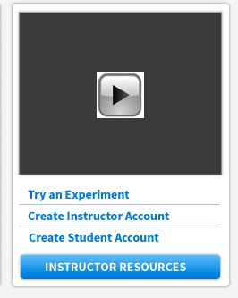

Specification:

Content box:

Margin:

Padding:

Width:

Height:

Background color:

Video box:

Width:

Height:

Video to play:

Try an experiment:

Text: “Try an experiment”

Color:

Top:

Left:

Width:

Height:

Font-name:

Font-weight:

Font-size:

URL:

Horizontal line 1:

Color specification:

Top:

Left:

Width:

Height:

Create Instructor Account:

Text: “Create Instructor Account”

Color:

Top:

Left:

Width:

Height:

Font-name:

Font-weight:

Font-size:

URL:

Horizontal line 2:

Color specification:

Top:

Left:

Width:

Height:

Create Student Account:

Text: “Create Student Account”

Color:

Top:

Left:

Width:

Height:

Font-name:

Font-weight:

Font-size:

URL:

Horizontal line 2:

Color specification:

Top:

Left:

Width:

Height:

Instructor resources:

Text: “SEE MORE”

Color:

Top:

Left:

Width:

Height:

Font-name:

Font-weight:

Font-size:

Color specification: linear from X to Y

Border specification:

URL:

## Experimental Design

Visual provided:

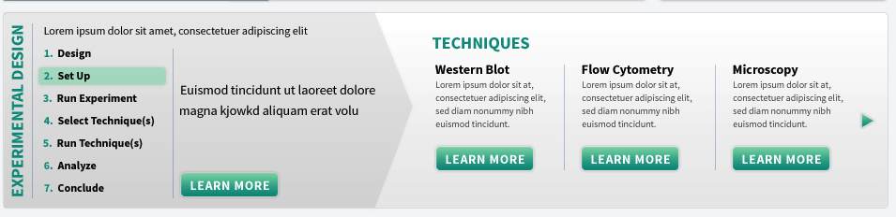

Specification:

Content box:

Margin:

Padding:

Top:

Left:

Experimental Design:

…

Text on top of exp design:

Text: “Each experiment consists of 7 steps:”

Color:

Top:

Left:

Width:

Height:

Font-name:

Font-weight:

Font-size:

Color specification: linear from X to Y

Border specification:

Numbers:

Top:

Left:

Step:

Color:

Font-name:

Font-weight:

Font-size:

Selected number:

Top:

Left:

Background color:

Margin specification:

Padding specification:

Border specification:

Width:

Height:

Vertical bar 1:

Asset name or color specification:

Top:

Left:

Width:

Height:

Vertical bar 2:

Asset name or color specification:

Top:

Left:

Width:

Height:

Detail text specification:

Position depending on length descripton:

Learn more:

Text: “LEARN MORE”

Color:

Top:

Left:

Width:

Height:

Font-name:

Font-weight:

Font-size:

Color specification: linear from X to Y

Border specification:

URL:

Content:

**1.** **Design** – State the objective that the experiment will address, your hypothesis for the experiment, and think about the technique that will best suit your experiment. **URL:**

**2.** **Set Up** – Specify the strain(s), treatment(s), treatment concentration(s), treatment start time, treatment duration and collection time for your experiment. **URL:**

**3. Run Experiment** – Perform your experiment and collect your samples. **URL:**

**4. Select Technique(s)** – Select the appropriate experimental technique that is best suited for your experiment. **URL:**

**5. Run Technique(s)** – Perform western blotting, flow cytometry and/or microscopy. **URL:**

**6. Analyze** – Analyze the results of your experiment. **URL:**

**7. Conclude** – Form a conclusion that addresses how your results fit your original hypothesis. **URL:**

Techniques:

Text: “TECHNIQUES”

Color:

Top:

Left:

Width:

Height:

Font-name:

Font-weight:

Font-size:

Western Blot title:

Text: “WESTERN BLOT”

Color:

Top:

Left:

Width:

Height:

Font-name:

Font-weight:

Font-size:

Western Blot text:

Text: “Western blotting detects overall changes in the amount or chemical modifications of a particular protein.”

Color:

Top:

Left:

Width:

Height:

Font-name:

Font-weight:

Font-size:

Learn more:

Text: “LEARN MORE”

Color:

Top:

Left:

Width:

Height:

Font-name:

Font-weight:

Font-size:

Color specification: linear from X to Y

Border specification:

URL:

Vertical bar 1:

Asset name or color specification:

Top:

Left:

Width:

Height:

Flow Cytometry title:

Text: “FLOW CYTOMETRY”

Color:

Top:

Left:

Width:

Height:

Font-name:

Font-weight:

Font-size:

Flow Cytometry text:

Text: “Flow cytometry uses lasers to count and analyze the size, shape and properties of individual cells within a heterogeneous population of cells.”

Color:

Top:

Left:

Width:

Height:

Font-name:

Font-weight:

Font-size:

Learn more:

Text: “LEARN MORE”

Color:

Top:

Left:

Width:

Height:

Font-name:

Font-weight:

Font-size:

Color specification: linear from X to Y

Border specification:

URL:

Vertical bar 1:

Asset name or color specification:

Top:

Left:

Width:

Height:

Microscopy title:

Text: “Microscopy”

Color:

Top:

Left:

Width:

Height:

Font-name:

Font-weight:

Font-size:

Microscopy text:

Text: “Microscopy uses microscopes to view cells, tissues and organisms that otherwise cannot be observed with the human eye.”

Color:

Top:

Left:

Width:

Height:

Font-name:

Font-weight:

Font-size:

Learn more:

Text: “LEARN MORE”

Color:

Top:

Left:

Width:

Height:

Font-name:

Font-weight:

Font-size:

Color specification: linear from X to Y

Border specification:

URL:

Vertical bar 1:

Asset name or color specification:

Top:

Left:

Width:

Height:

More techniques button:

Skipped for now